**Test Automation Results**

**Using Cypress.io**

Please find below the test result after running all integration tests via the cypress test automation framework. Execute using the command: **npm run cy:open**

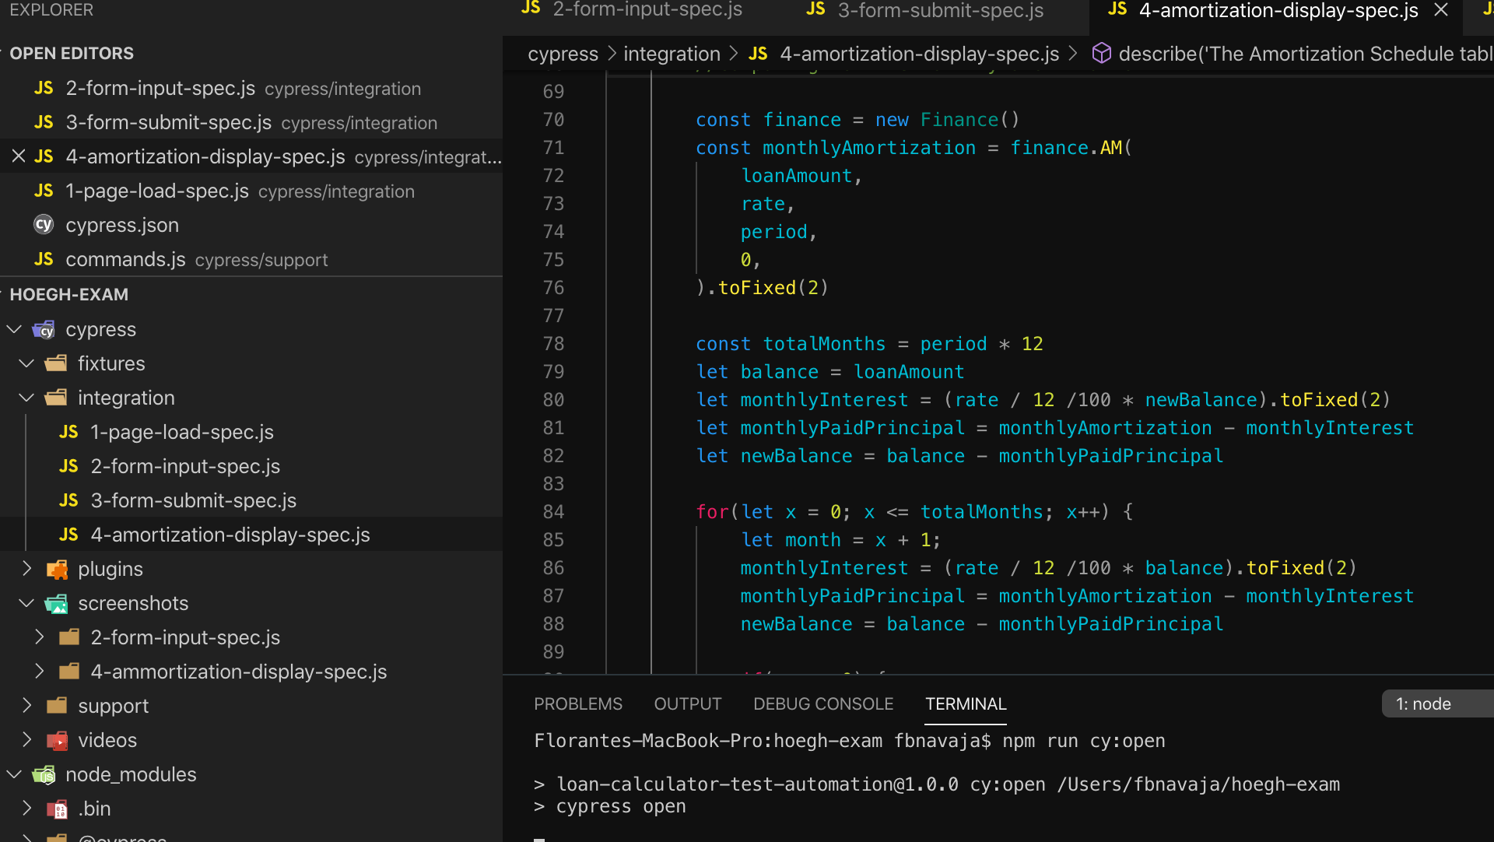

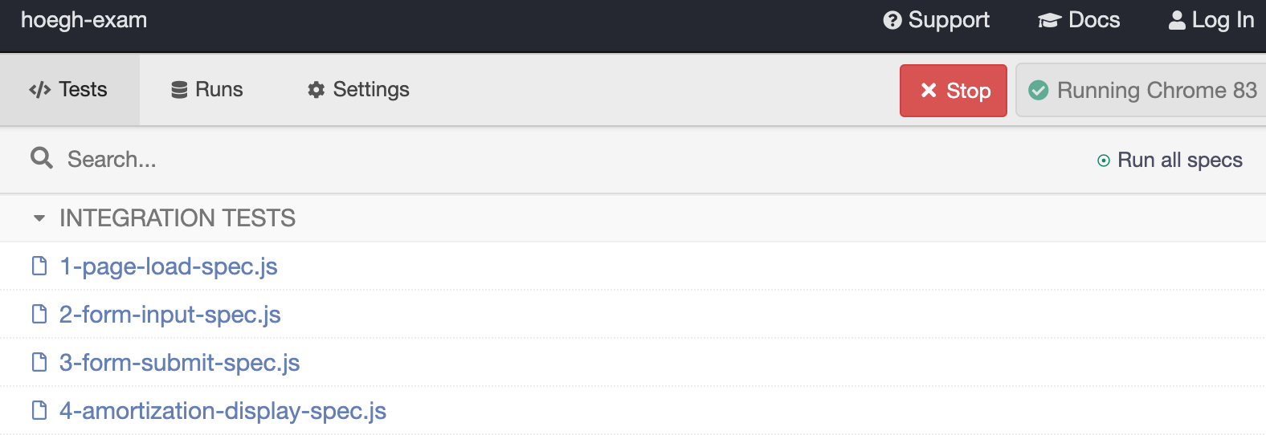

**I.**

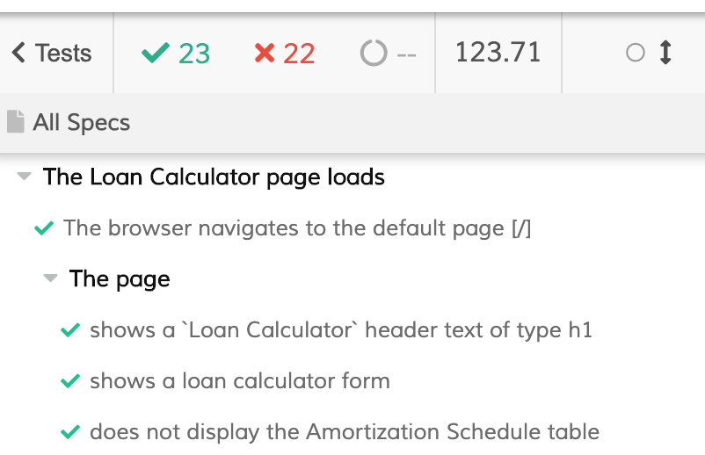

**II.**

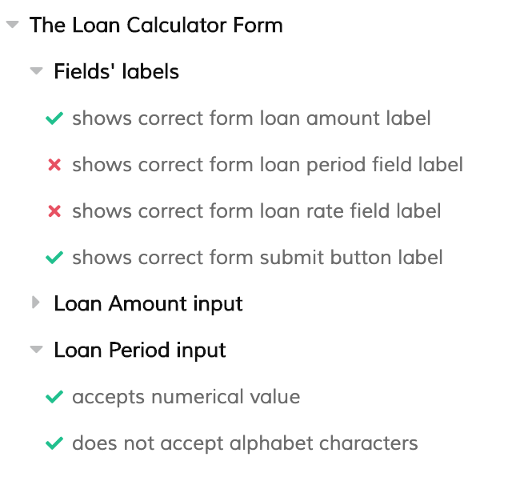

**III.**

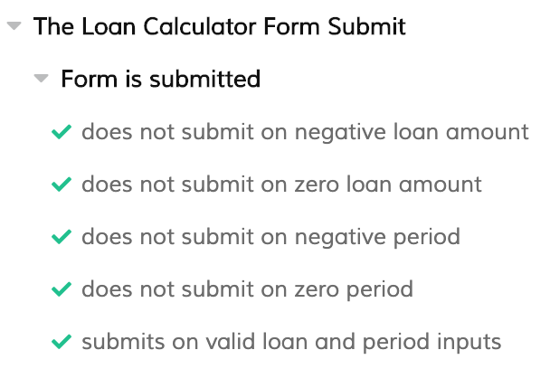

**IV.**

The requirement has 3.5% as the fixed interest rate. But the current application version assumes 7.5%. Likewise the computation for the interest and remaining amount or balance is incorrect.

The testing formula was validated against multiple sources of loan calculator found in the internet.

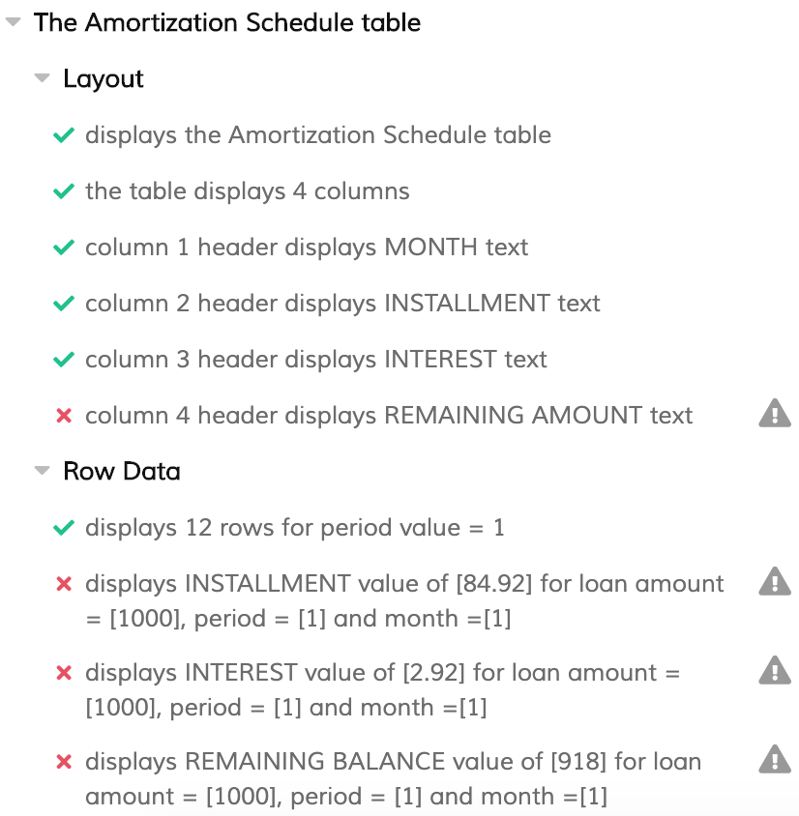

**Current Home Loan Application Version result –** Assumed the 7.5% fixed interest rate

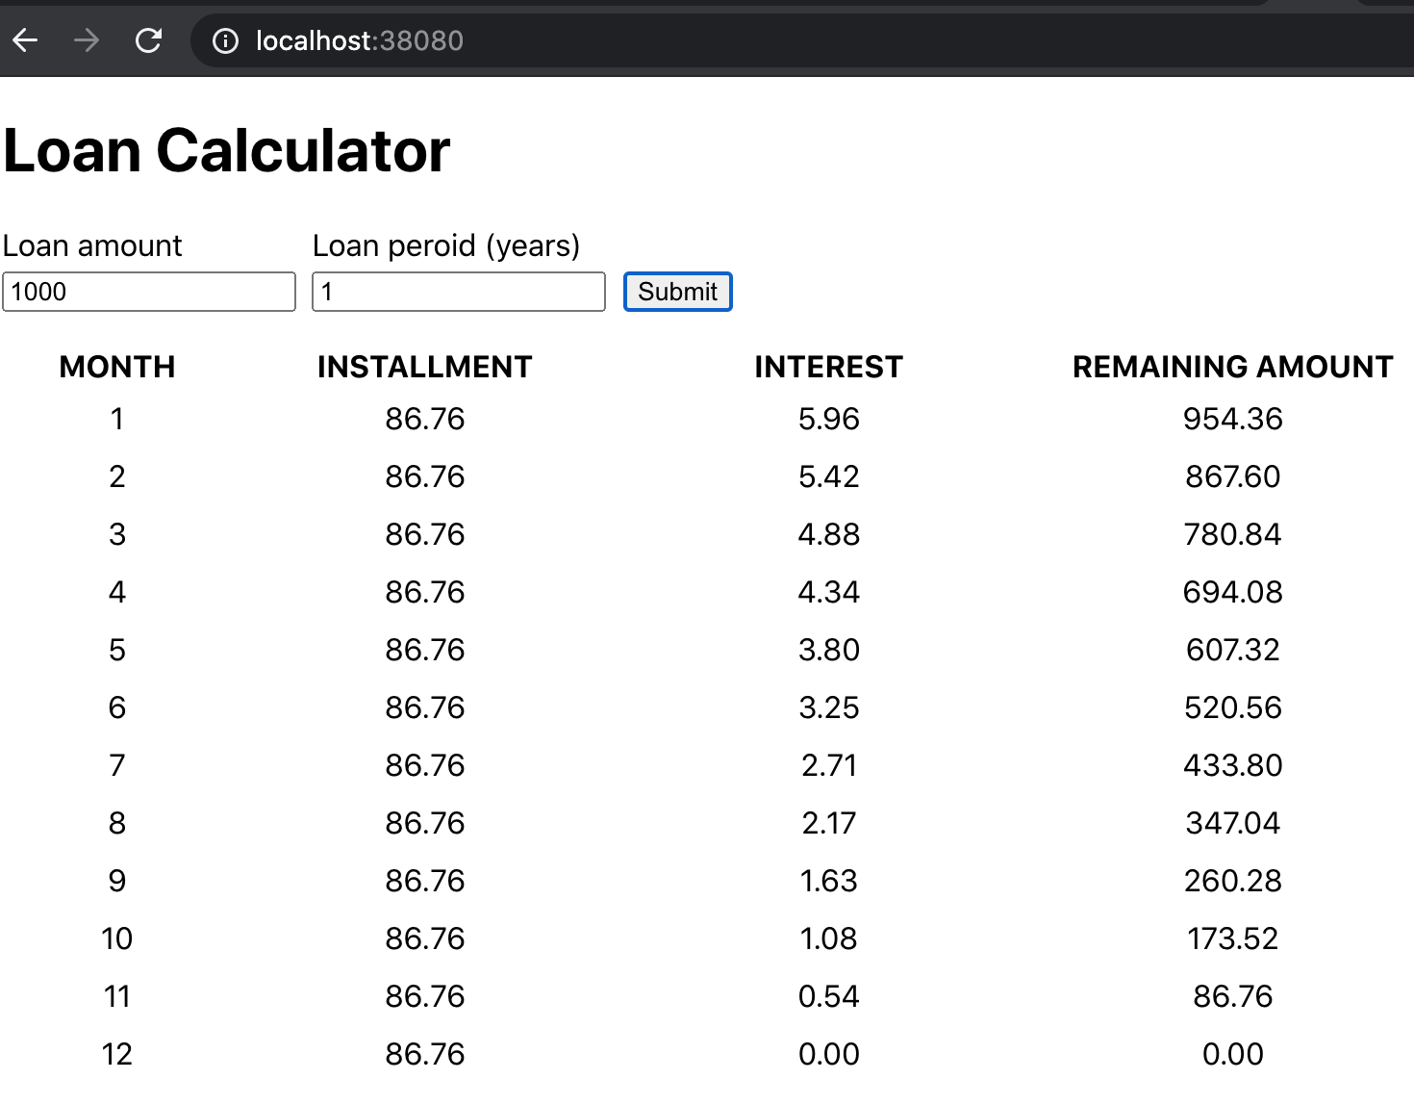

**Internet Source 1 -** <https://www.bankrate.com/calculators/mortgages/loan-calculator.aspx>

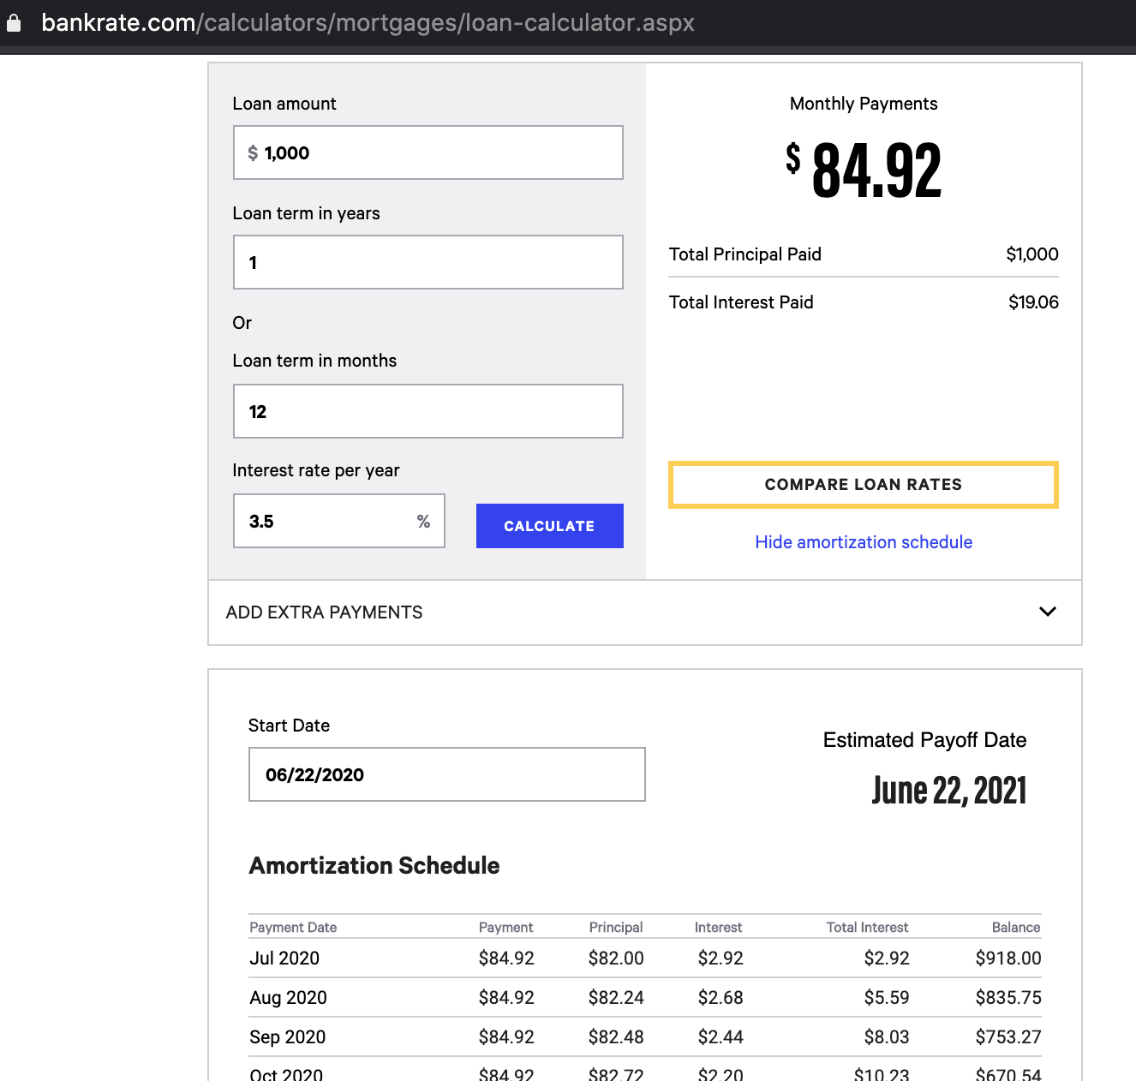

**Internet Source 2 -** <https://www.farmcrediteast.com/products-and-services/Loans/loan-calculator>

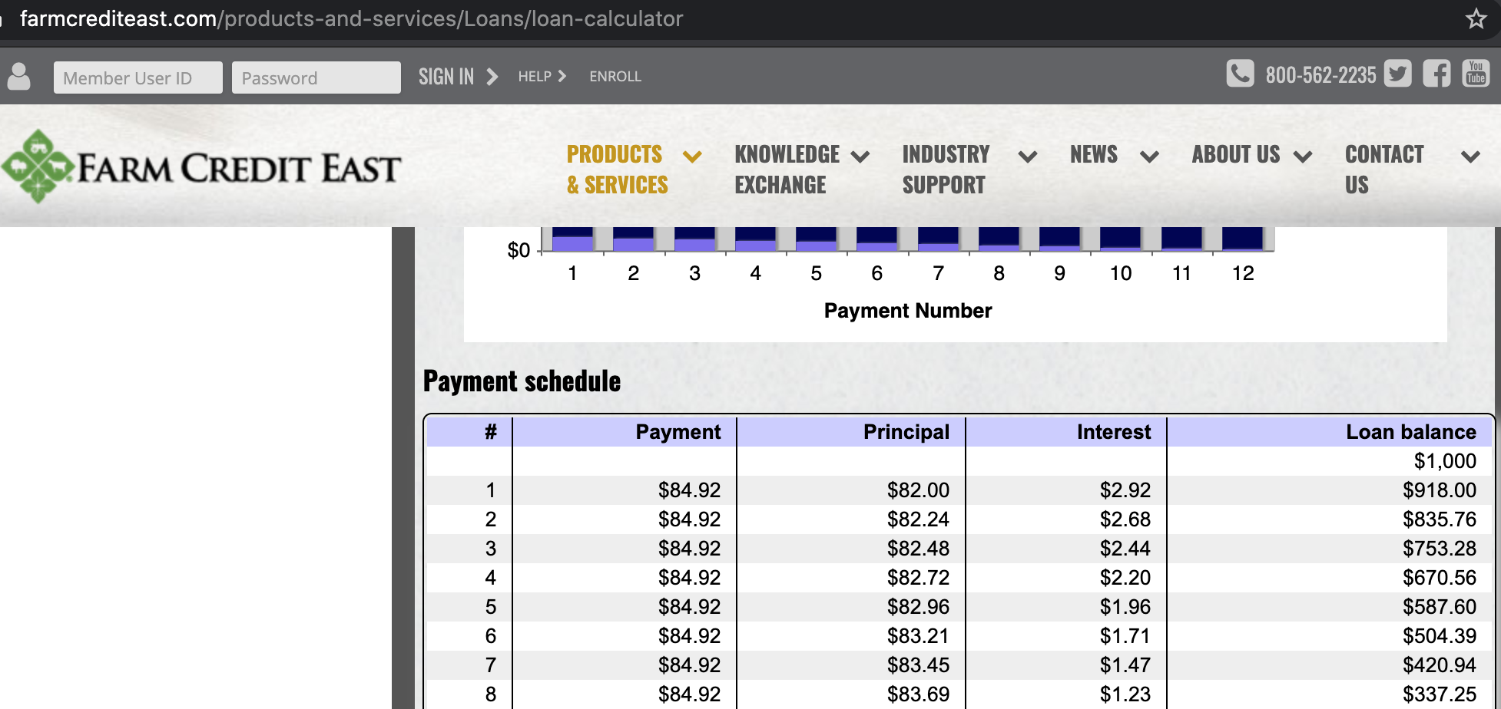

**V.**

Videos created

